Lecture # 6:

Objective:

- Employee Salary Example
- Exception Handling
- Use of Check Box
  - Coffee Shop Example
- Use of Radio Button
  - Background and Fore color Example

Employee Salary

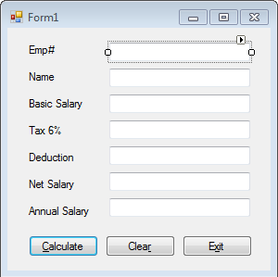
using System;
using System.Collections.Generic; using System.ComponentModel; using System.Data;
using System.Drawing; using System.Linq; using System.Text;
using System.Windows.Forms;

namespace EmployeeForm
{
public partial class Form1 : Form
{

float bsal, tax, deduction, nsal, asal;

public Form1()
{
InitializeComponent();
}

private void btnCalculate_Click(object sender, EventArgs e)
{
if (txtEmpNo.Text == string.Empty)
{
MessageBox.Show("Employee Number"); txtEmpNo.Focus();
}
else if (txtName.Text == string.Empty)
{
MessageBox.Show("Name"); txtName.Focus();
}
else if (txtSalary.Text == string.Empty)
{
MessageBox.Show("Salary"); txtSalary.Focus();
}
else if (txtDeduction.Text == string.Empty)
{
MessageBox.Show("Deduction"); txtDeduction.Focus();
}
else
{

try
{

}

bsal = float.Parse(txtSalary.Text); deduction = float.Parse(txtDeduction.Text); tax = float.Parse((bsal * 0.06).ToString()); txtTax.Text = tax.ToString();
nsal = bsal - deduction - tax; txtNetSalary.Text = nsal.ToString(); asal = nsal * 12;
txtAnnualSalary.Text = asal.ToString();

catch (Exception ex)
{
MessageBox.Show(ex.Message);
}
}
}

private void btnClear_Click(object sender, EventArgs e)
{
txtEmpNo.Text = string.Empty; txtName.Text = string.Empty; txtSalary.Text = string.Empty; txtTax.Text = string.Empty; txtDeduction.Text = string.Empty; txtNetSalary.Text = string.Empty;

txtAnnualSalary.Text = string.Empty;
}

private void btnExit_Click(object sender, EventArgs e)
{
Application.Exit();
}
}
}

Coffee Shop:

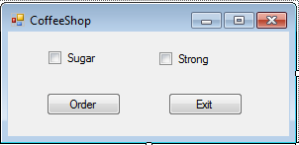
using System;
using System.Collections.Generic; using System.ComponentModel; using System.Data;
using System.Drawing; using System.Linq; using System.Text;
using System.Windows.Forms;

namespace CoffeShop
{
public partial class Form1 : Form
{
public Form1()
{
InitializeComponent();
}

private void btnExit_Click(object sender, EventArgs e)
{
Application.Exit();
}

private void btnOrder_Click(object sender, EventArgs e)
{
string strmsg = "Your Order Includes "; if (chkbxSugar.Checked)

{
strmsg = strmsg + "Sugar ";
}
if (chkbxStrong.Checked)
{
strmsg = strmsg + "Strong";
}
MessageBox.Show(strmsg);
}
}
}

Change Color
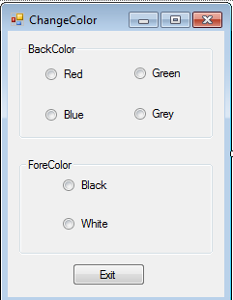

using System;
using System.Collections.Generic; using System.ComponentModel; using System.Data;
using System.Drawing; using System.Linq; using System.Text;
using System.Windows.Forms;

namespace ChangeColor
{
public partial class Form1 : Form
{
public Form1()
{ InitializeComponent(); }

private void btnExit_Click(object sender, EventArgs e)
{ Application.Exit(); }

private void rdbtRed_CheckedChanged(object sender, EventArgs e)
{ this.BackColor = Color.Red; }

private void rdbtGreen_CheckedChanged(object sender, EventArgs e)

{ this.BackColor = Color.Green; }

private void rdbtBlue_CheckedChanged(object sender, EventArgs e)
{ this.BackColor = Color.Blue; }

private void rdbtGrey_CheckedChanged(object sender, EventArgs e)
{ this.BackColor = Color.Gray; }

private void rdbtBlack_CheckedChanged(object sender, EventArgs e)
{ this.ForeColor = Color.Black; }

private void rdbtWhite_CheckedChanged(object sender, EventArgs e)
{ this.ForeColor = Color.White; }
}}

